Report Builder:

Architecture –   
Below is a snap from report runner. This illustration will show what we will need in **Report Builder** to run any report. We will need strings for blocks 2, 3 and 4 (2 strings for block 4) to run any report. Assume, you have created a report with the name **Test Report** and created an SQL query in query builder UI, while creating the query, Report builder also creates the required strings to be used in **report runner.**

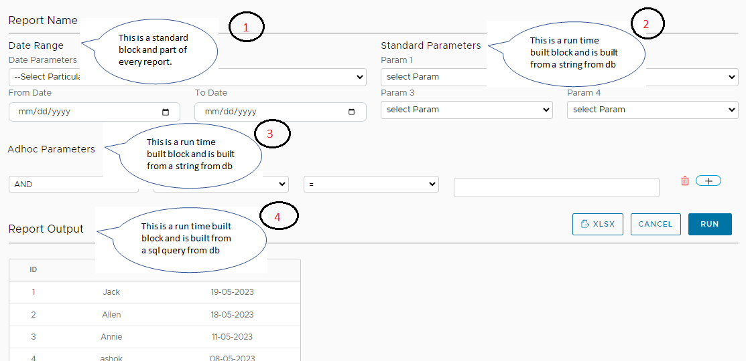

**Report Builder UI:**

The report builder has a header table and a line table. The header will have fields like Report name, description, Is Active, folder Name and who columns. The report header grid view will have a action button called “Setup” (like workflow link on other UIs).

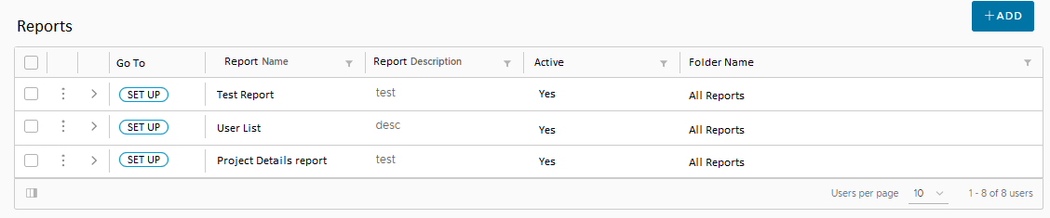

Click the Setup button to go to report builder setup, this UI opens only if Line record is not available.

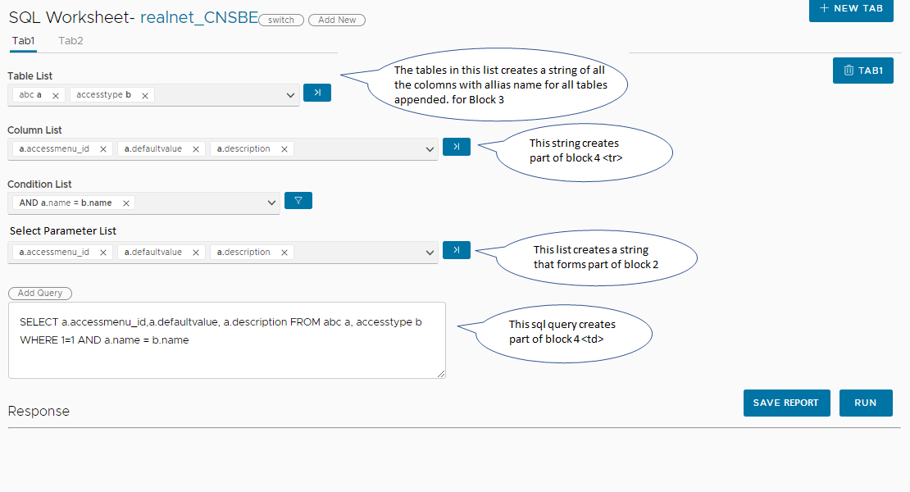





If Line record is available, it opens below UI in Edit mode:

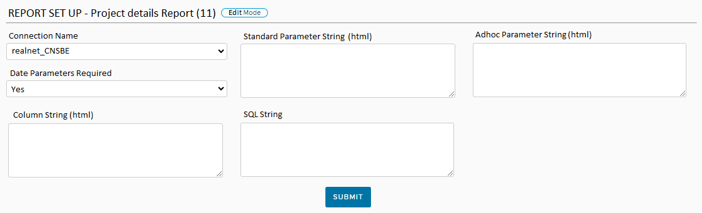

Table will have columns like:

Id, conn_name, date_param_req, std_param_html, adhoc_param_html, column_str, sql_str, all who columns